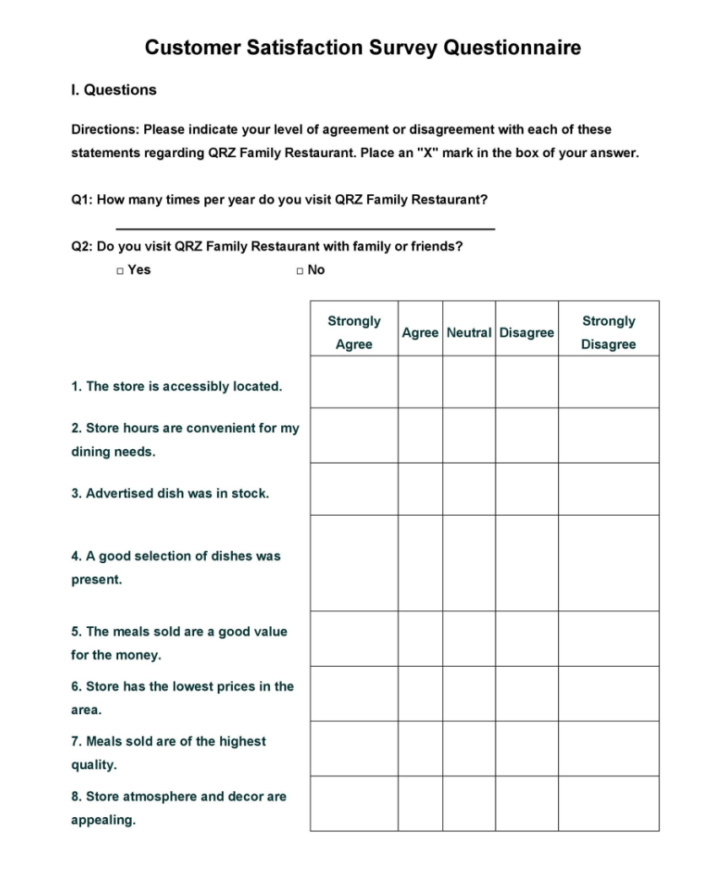

Here I have chosen to review a genetic Likert scale (Template lab, 2023). One of the reasons I chose the Likert questionnaire is that it provides a great way to gauge a respondent’s feeling with little probability of bias. Another positive is that it’s simple to construct and accessible for users. As the focus of this questionnaire is to understand customers’ feelings, it is best not to be use a dichotomous questionnaire. This would tend to provide binary answers leaving no room for the spectrum of customer feelings to be expressed.

It is good to point out that this questionnaire does not include leading or loaded questions within the set. A leading question is one in which the question itself will potentially bias the response. A loaded question has a stated assumption that will influence the answer obtained e.g. “Why do you not like unclean fast food chain restaurants?” This example demonstrates that the assumption has forced the respondent to agree with the reality the researcher has set out, regardless of the respondents’ own feelings.
In conclusion I believe this is a very appropriate questionnaire which can elicit an expression of a wide range of feelings that a consumer may have to an establishment.

Reference
Template lab. (2023). 30+ Questionnaire Templates (Word). [Online]. Template lab. Available at: https://templatelab.com/questionnaire-template/ [Accessed 5 November 2023].

